Arman,
You really did a good job on this. I like your work and design idea’s. I can say we just have remaining 4 to 5 changes after our home page will be ready to fly. Please Find below correction
1. Actually, this is for Australia and this will be reflected on AUS page when we design and confirm. For USA Can you please find below.
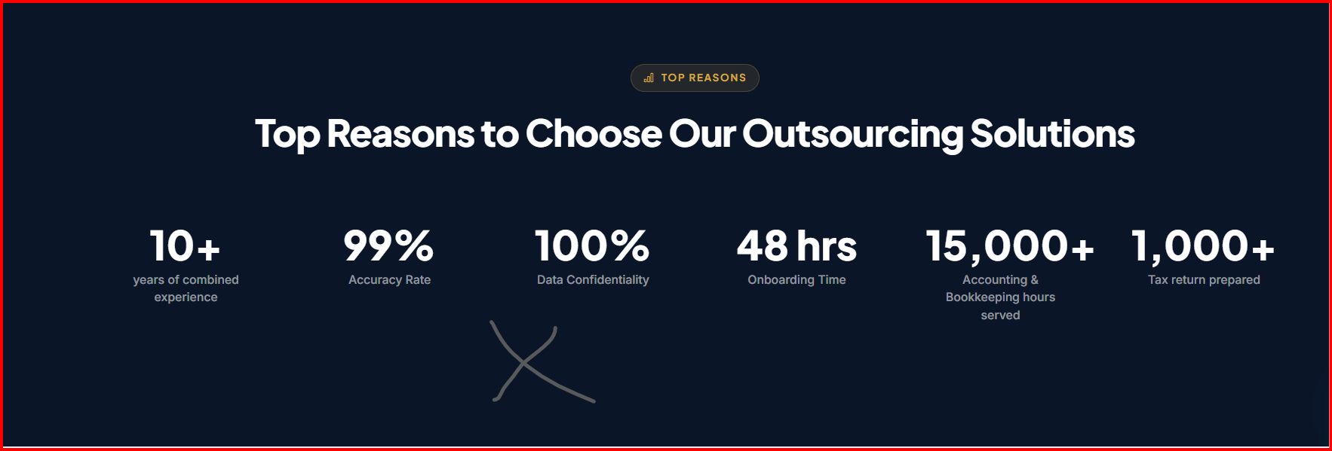
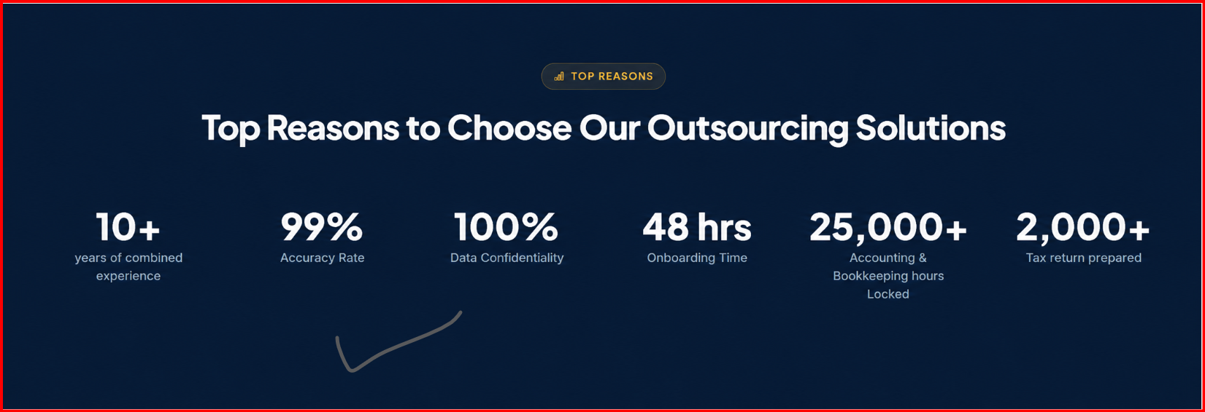
2. Just little bit changes required below.

3. We have to keep software icon more visible without background disturbance. Please find icon for the same. And here for Xero there are five images on website but I want only three icons on the same which I attached below remove all Xero Icon and adjust by sequence which I shared from 1,2,3.
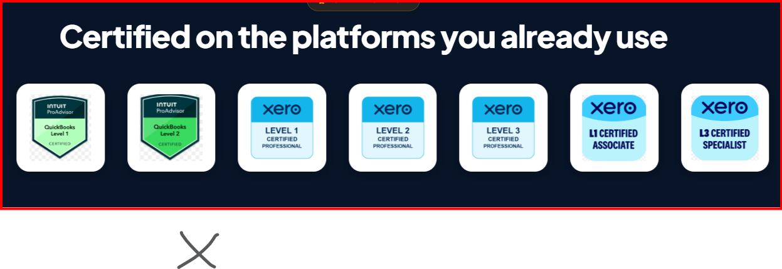



4. I have atached icon for software stack behind our outsourced solutions by servcies by country for better icon visibility
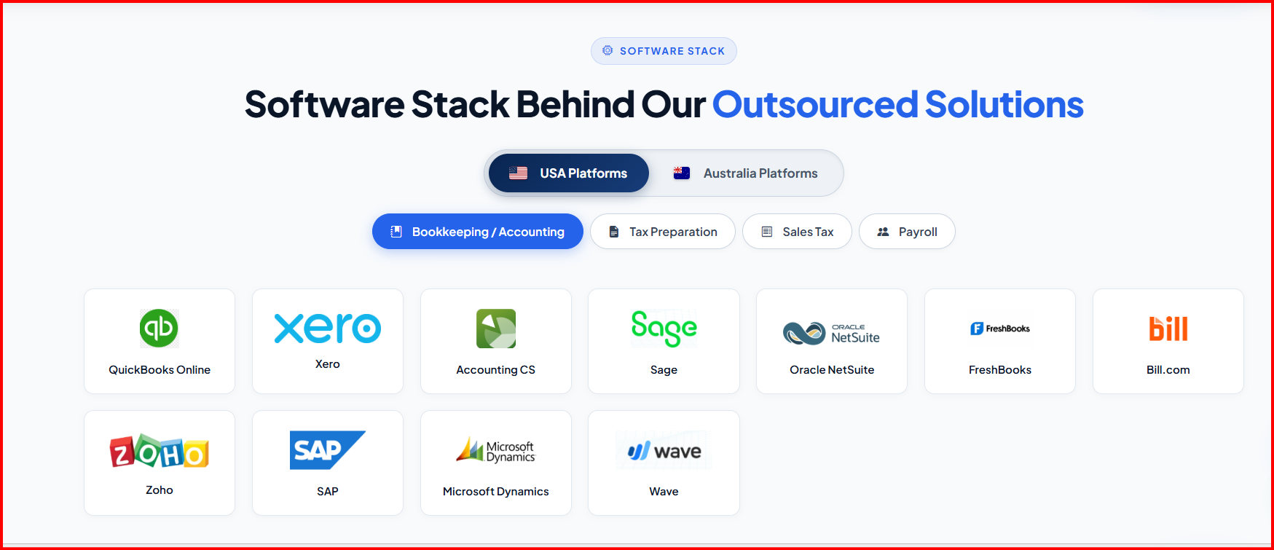
1) FreshBooks Icon are not in ideal size please find below icon

2) Tax Preparation part : Please find ideal size and icon for the same
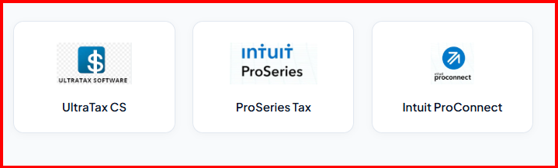

UtraTax CS : Intuit Pro Series Tax :


Intuit Pro Connect :

3) Now Payroll section: Square, ADP and TriNet are not in idea size we have to adjust accordingly
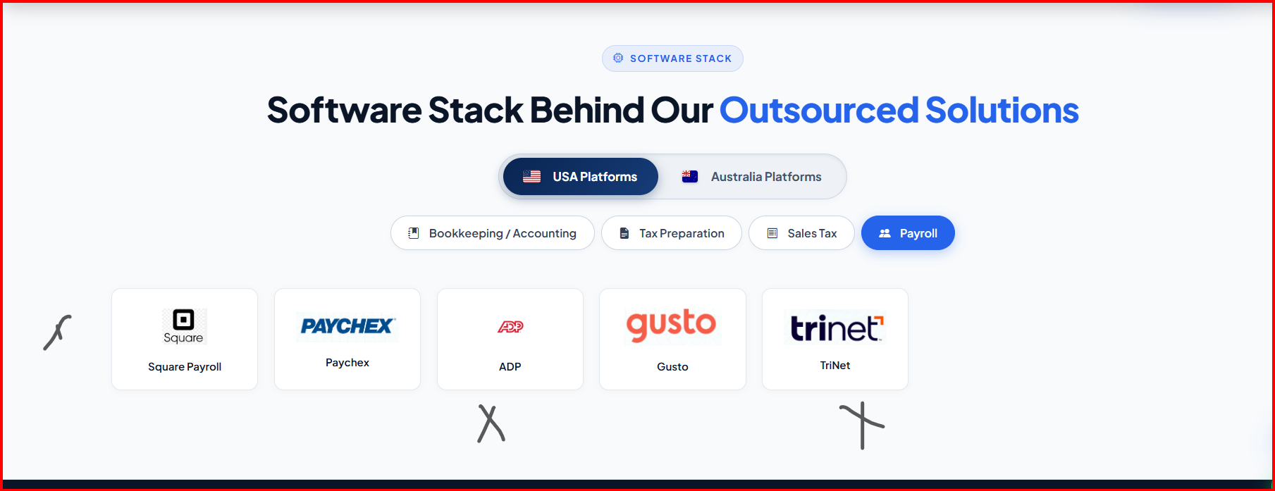

Square

ADP

Trinet

Note: As we discussed AUS software’s will be remove here and show on AUS page so please remove from here and only show US software’s. Same applicable for testimonial’s as well that will be show on AUS page as well. Rest things are good to go and ready to fly no changes and footer and menu bar will cover later at the end of finalization of website. As I already discussed with Ehjaz bhai about extra pages on AUS side we both agree on this no worries.

